The City of Baltimore’s Soil Safety Policy for Food Production

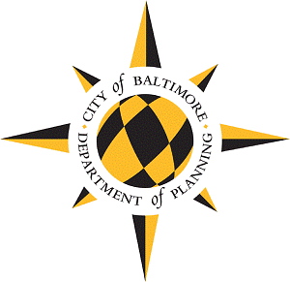
Table of Contents
Introduction: Page 1
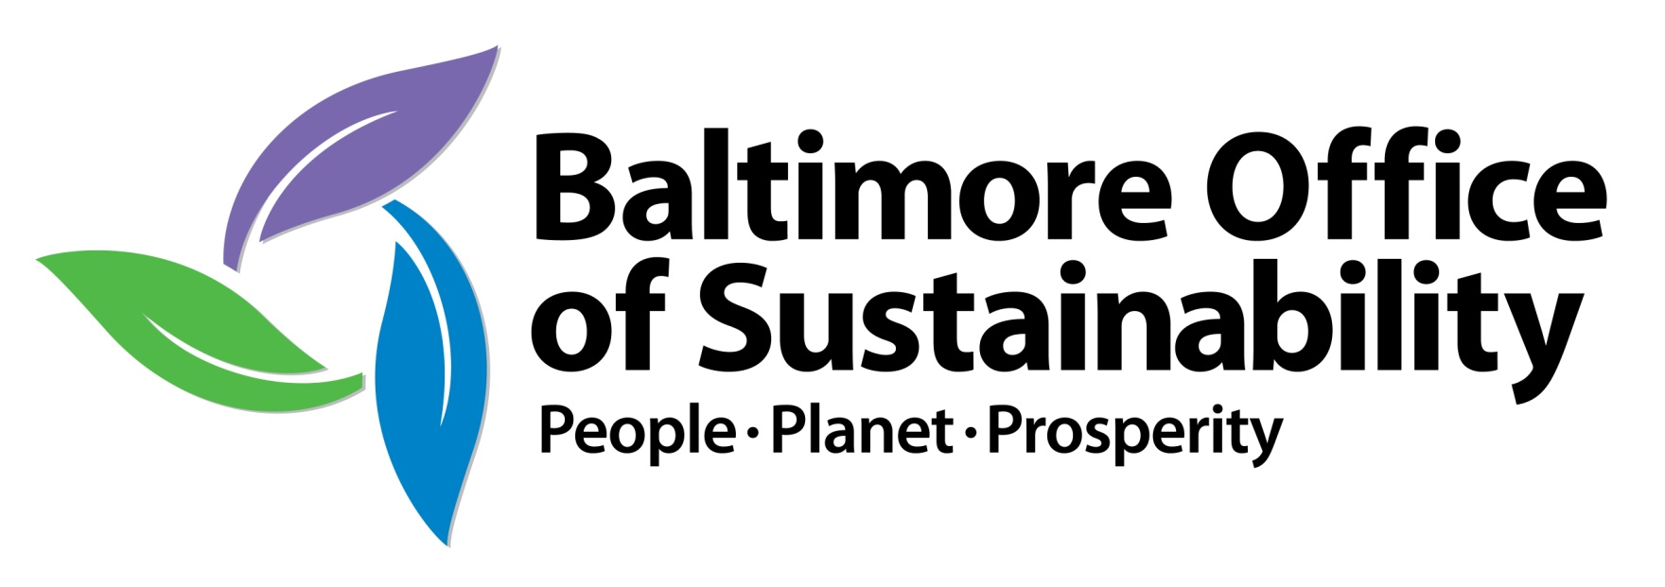
Applicability: Page 2
Site Assessment: Page 2
Soil Testing and Analysis: Page 4
Best Practices: Page 6
Remediation: Page 7
Soil Safety Plan Submission Guidelines: Page 8
Appendix A: Additional Resources: Page 9
Appendix B: Soil Testing Laboratories: Page 11

Introduction
The urban agriculture movement – including backyard gardening, schoolyard gardening, community gardening, urban farming, and other forms of food production – is growing in popularity and momentum across the globe. The City of Baltimore has a robust and growing urban agriculture sector, and recently released Homegrown Baltimore: Grow Local, an urban agriculture policy plan for the city (learn more here: http://www.baltimoresustainability.org/homegrown-baltimore-grow-local). This document addresses the plan’s Recommendation 3b, “Develop Soil Standards: Provide effective, accessible standards and guidance around identifying and managing soil contamination”, and was released to the public in 2014.
Baltimore City was founded in 1729, and, even in our parks and stream valleys, very little soil remains that has not been disturbed by human activity. Most urban agriculture in Baltimore is taking place on vacant lots on which once stood houses or other structures – the existing soil at these sites is generally drastically different than what might be ideal for food production. Due to this history, soil contamination, especially by heavy metals such as lead and arsenic, is a potential health concern for the growers and consumers of food in the city.
The simplest way to avoid risk from contaminated soils is to avoid contact with them. Some food producers in the City are growing food in soil purchased from professional landscaping supply companies, as an alternative to growing in existing soils. In other cases, growers are using hydroponic techniques that use no soil at all. While these methods make sense in many cases, some people still wish to grow in existing soils. Reasons for this may include the high cost of importing soil, or a desire to enhance existing resources rather than bring in new ones.
This document is intended to lay out safety standards to which the average food producer growing food in existing city soils could reasonably adhere. Following the practices recommended in this document does not guarantee that a safe condition exists, as there could still be contaminants missed by these methods. Risk exists no matter where our food comes from – growing our own food at least gives us more control over its growing conditions. We have an obligation to take rational precautions for safety, while acknowledging that it is impossible to avoid all forms of risk.
We are indebted to the Johns Hopkins Center for a Livable Future for their guidance and review of this document, and for sharing the resource list found at the end. Anyone reading this document is encouraged to also review the resources that the Center for a Livable Future has developed: www.jhsph.edu/clf/urbansoilsafety/.
Many others also provided feedback on this document. Thank you to all of them, and to everyone who is working to make Baltimore a greener place!

Applicability
This document is intended to:
A. Provide guidance about how to reduce risk when growing food in existing city soils.
B. Lay out the standards for receiving a Use Permit for a food-producing community garden or urban farm in Baltimore City.
Purpose A applies to anyone growing food in existing city soils, including in backyards, schoolyards, or on institutional land such as a hospital campus. In such cases, this document provides advice, but is not required.
Purpose B applies to those who wish to make community gardening or urban farming the primary, permanent use of a parcel of land. To do so, a Use Permit must be obtained from the Permits Office of the City of Baltimore, as per the requirements of the new Baltimore City Zoning Code (currently under review by the Baltimore City Council, and pending adoption). This requirement applies whether the site is on privately-owned land or public land. In order to receive a permit, the applicant must submit a Soil Safety Plan and have it approved. This document lays out the standards that must be followed for approval. Even if you intend to grow food in clean soil from an outside source, you must still assess and test the existing soil at your site if there is any soil within 25 feet of where you intend to grow that is not capped by an impermeable barrier such as concrete or asphalt, since very high levels of contamination could still pose a risk.

Site Assessment
Site assessment is the first and most important step in identifying and managing soil contamination. A thorough site assessment can help you understand the factors that may have produced contamination at the site at which you wish to grow food, and will guide you in choosing which potential contaminants to test for. If a site assessment turns up significant risks, you may wish to choose a different site and start over, or you may wish to proceed to soil testing, as described below.
One way to assess your site is to have a qualified professional conduct an Environmental Site Assessment (ESA). ESAs come in phases. A Phase I ESA is an investigation of potential risks based on history and visual assessment, generally performed by a professional engineer or geologist. No soil testing is involved. The purpose of a Phase I ESA is to provide recommendations, if any, for further testing. A Phase I ESA typically costs thousands of dollars, and is generally performed for new development projects. A Phase I ESA can provide you with great peace of mind, but may not be within the means of all growers. Below, we will walk you through how to perform your own site assessment. There are two parts to site assessment – site history and present characteristics.
Site History
Determining the history of a site means knowing what was located there in the past and also what was around it. Strictly residential uses are not likely to present significant risks beyond the heavy metals that should be tested for at all sites. However, uses such as gas stations, dry cleaners, mechanical shops, factories, and junkyards, even those long closed, could indicate the potential for other types of contamination. There are several methods for learning a site’s history.
- The Johns Hopkins Center for a Livable Future provides an interactive map showing the locations of community gardens, school gardens, and urban farms in Baltimore City, along with current and prior hazardous waste sites identified by the Environmental Protection Agency and the Maryland Department of the Environment. Check this map to see if there are any known hazards on or around your site: www.jhsph.edu/clf/soilcontaminants
- Oral history is an invaluable tool for determining site history. Talk to neighbors and local community associations to find out what they know about past uses on or around your site. You may also consult a local historical society.
- Historic maps can be an excellent method for determining the past conditions on and around your site. The most commonly used maps for identifying past building uses are the Sanborn Maps. Sanborn Maps are large-scale plans, drawn at a scale of 50 feet to an inch. They were created to help fire insurance companies to assess risk. They identify street names and numbers, building materials, and, in many cases, building uses.
- Sanborn Maps for Baltimore City are available from 1890-1982. The Enoch Pratt Free Library has all of these maps available to the public. Maps from 1890-1953 may be accessed digitally at http://www.prattlibrary.org/locations/maryland/index.aspx?id=4324. In addition, a tutorial on how to use the digital maps is available here: http://www.prattlibrary.org/special/camtasia.aspx?id=1316. However, the digital maps are not in color, and may be difficult to read in some cases. They also do not include the final edition of the Baltimore City Sanborn Maps, which was updated in 1982. In order to access color versions of the maps, and to see the 1982 set, you must visit the Maryland Department at the Central Branch of the Enoch Pratt Free Library. Staff there can assist you in finding your site, and in interpreting the maps.
- Finally, internet research can help you round out your understanding of your site’s history. You can search for the block number and street name of your site (ex. “400 Beech Street”) and see what comes up. This is not the most reliable way to find information, but it may turn up something you could otherwise have missed.
Present Characteristics
In addition to understanding your site’s past, it is useful to look carefully at its present condition. Factors to identify include:
- Adjacent uses. What is around your site? Are there any businesses or other uses that might be a cause for concern?
- Slopes. The presence of slopes can determine whether or not adjacent uses are cause for concern. For instance, if your site was next to a gas station, this could pose a concern for contamination if the gas station was uphill from the site. On the other hand, if the gas station was downhill from the site, it is highly unlikely to have caused contamination.
- Ruts, bare spots, or standing water. These can indicate areas where rainwater tends to collect during storms. If contamination is suspected, it is likely to be higher in these areas.
- Illegal dumping. If your site has been subjected to illegal dumping of trash or other debris, mark down what was found at the site and where before you clean it up. Certain items, such as paint cans or old batteries, might have contaminated the soil in that spot.

Take notes about your site’s history and present characteristics, using the methods described above. If applicable, draw a map of your site which shows slopes and makes note of any “hot spots” where contamination is of special concern due to soil erosion or illegal dumping.
Compare your notes to the following EPA chart to identify any contaminants of concern for your site:
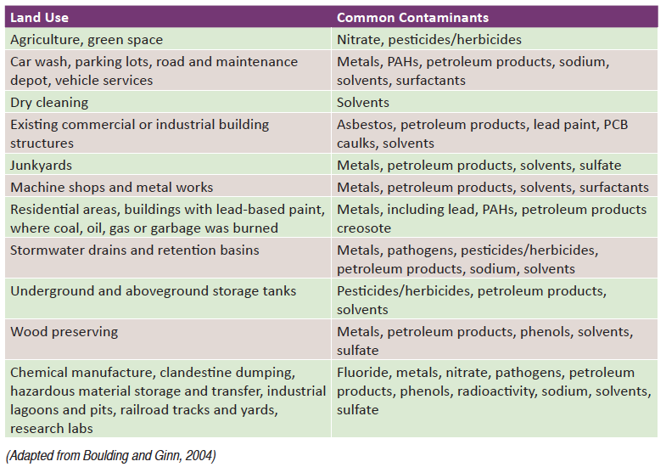
PAHs = polynuclear aromatic hydrocarbons
PCB = polychlorinated biphenyls.
Source: “Brownfields and Urban Agriculture: Interim Guidelines for Safe Gardening Practices” EPA, 2011. http://www.epa.gov/swerosps/bf/urbanag/pdf/bf_urban_ag.pdf

*Please note that the Land Use category in the chart above that begins with “Residential areas” refers specifically to residential areas where burning of coal, oil, gas, or garbage occurred, not to all residential areas.

Soil Testing and Analysis
ALL sites in Baltimore City where you intend to grow food in or adjacent to existing soils must be tested for lead, arsenic, cadmium, and chromium, as these are potentially dangerous heavy metals that are commonly found in urban soils. A list of any additional contaminants to test for will be generated by your site assessment. It is important to note that soil testing labs often only test for lead and other more common contaminants. They do not test for every possible contaminant. For this reason, one cannot assume a negative test result is a “clean bill of health” without considering the presence of other contaminants. This is why investigating site history is an important complement to soil testing.
If you chose to hire a professional to perform a Phase I Environmental Site Assessment (ESA), those results can be used either to guide that person (or a different professional, if you so choose) in performing a Phase II ESA, which tests the soil. A Phase II ESA typically costs $10,000 or more, and is beyond the means of many growers. The rest of this section will address how to perform testing yourself, whether based on a Phase I ESA or on your own site assessment.
At-home soil testing kits may be purchased from various stores or from the internet, but these should NOT be used for assessing soil safety, as they are primarily meant for assessing nutrients in the soil, not contaminants, and may be unreliable.
Professional soil testing can be conducted by a number of academic center labs and private labs (see the list in Appendix B for examples). Different labs use different methods of testing. We recommend choosing a lab which uses Mehlich 3, Morgan, or Modified Morgan extraction, as recommended by the EPA. Other methods may produce less reliable results. Be sure to ask the lab you are considering using which method of extraction they use before choosing them (all of the labs listed in Appendix B use the methods recommended above).
Labs vary in their prices and in which other factors they test for (such as nutrients, organic matter, pH, etc.) which may be of interest to you, so be sure to check on these factors to make sure that you’re getting the deal that makes the most sense for you and your site. Universities will usually be much cheaper than private labs, but may test for fewer contaminants – always be sure to test for ALL the contaminants of concern identified by your site assessment. Some potential contaminants are more expensive to test for than others. Tests for heavy metals are common and relatively inexpensive. If your site assessment found potential contamination from less common sources, such as PCB caulks or PAHs, testing will be more expensive. If tests prove to be prohibitively expensive, you may wish to treat the site as if it were contaminated and either mitigate accordingly or choose another site.
In general, labs will ask you to collect at least a dozen soil samples from throughout your site, mix them, and send one container of soil to represent conditions across the site. However, if your site assessment turned up any “hot spots”, you may wish to test those separately. If the soil sample from your site at large comes back within acceptable levels, and the “hot spots” come back with high levels of contamination, you can avoid those particular spots and grow food in the rest of the existing soil. Alternately, you can exclude any potential “hot spots” from your testing entirely, and just avoid growing food in those areas.
Once test results have been obtained, the next step is to analyze them and assess risk. Below are guidelines for analyzing your results when it comes to lead, other contaminants, and concerns specific to urban farms. The science of soil safety is still developing, and there are many factors that influence the availability of contaminants in the soil or their uptake into plants (see Appendix A for further reading). It may not always be completely clear whether your situation is safe or unsafe, and it is up to you to determine what level of risk you find to be acceptable.
Lead (Pb)
Because lead is the most common soil contaminant in Baltimore, and more is known about it, we deal with it specifically in this document. Below are guidelines for how to interpret the levels of lead at your site, and what you must include in your Soil Safety Plan:
- 0-50 parts per million (ppm) or below of lead is equivalent to background levels of lead in soils and is of negligible concern. No action is required in your Soil Safety Plan.
- 50-400 ppm of lead represents low risk, and is suitable for food production. However, if children directly ingest soil, they may be at some risk. Consider following the best management practices described below, especially if children will be at the site. No action is required in your Soil Safety Plan.
- 400-999 ppm of lead represents low-moderate risk. Best practices must be followed, as described below, and must be listed in your Soil Safety Plan. Remediation is recommended but not required.
- 1,000-2,000 ppm represents moderate-high risk. In addition to best management practices, your Soil Safety Plan must include remediation, as described below.
- 2,000 ppm or greater is high risk. You must bring in clean soil from an outside source and maintain a strict plan to prevent that soil from becoming contaminated, as well as to prevent human exposure to the existing soil. These measures must be described in your Soil Safety Plan. You may also wish to consider using a different site.

Other Contaminants
Risk assessment for contaminants other than lead is incomplete when it comes to food production, as the science is still developing. The EPA has residential screening levels for many contaminants, which take home gardening into account. See below for these levels, which provide a starting place for thinking about potential risks at your site:
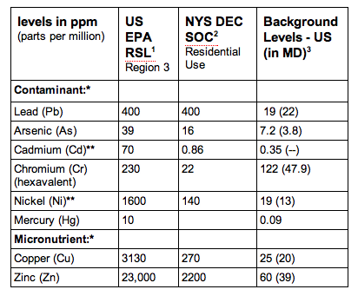
EPA RSL = Environmental Protection Agency Regional Screening Levels
NYS DEC SOC = New York State Department of Environmental Conservation Soil Cleanup Objectives
Sources:
1: “Guide to Soil Testing and Interpreting Results”, Cornell Extension, 2009.
2: “Interpreting the Results of Soil Tests for Heavy Metals”, University of Vermont Extension, 2011.
3: “Issue Paper on the Environmental Chemistry of Metals”, EPA, 2004.

Contaminants other than those addressed above should be dealt with on a case by case basis. For guidance, contact the University of Maryland’s Home and Garden Information Center, either online or at 1-800-342-2507.
Concerns Specific to Commercial Urban Farms
Because commercial farm workers are working on the farm far more hours than most home gardeners or community garden members, it is reasonable to assume that their health may be at greater risk than any other group from soil contamination. Those seeking to start urban farms on sites with low to moderate levels of soil contamination should include a worker safety plan in their Soil Safety Plan, and may wish to give stronger consideration to remediation.
Best Practices
When it comes to soil contaminants, direct ingestion of soil, skin contact, and inhalation are the methods of exposure that are most likely to cause negative effects to human health. The best practices listed below generally focus on limiting direct exposure to contaminated soil, so as to lower these risk factors. Not every practice is necessary at every site, but you should consider following at least some of these best practices even if your site assessment did not find any risk, since you can never completely rule out the possibility of contamination.
- Avoid hand to mouth contact while working in the soil.
- Wear gloves while working in the soil.
- Wash all produce thoroughly, ideally outside the home.
- Peel root vegetables and remove the outer leaves of leafy vegetables.
- Remove shoes and dirty clothes outside the home to avoid bringing contaminated soil indoors.
- Use drip irrigation to avoid splashing soil onto leaves and fruits.
- Lay down mulch or otherwise create a barrier over contaminated soil that prevents it from being stirred up. This is important not only in growing areas, but on adjacent paths.
- Use raised beds or other containers to lift crops up away from contaminated soils.
- Add organic matter, such as compost, and maintain a neutral soil pH to make contaminants less available to plants.
- Locate plots away from roads, and/or build a hedge or fence to screen plots the road.
- Create a “crop plan” that outlines which types of plants are safe to grow at your site, and which should be avoided, using the following guidelines:
  - Leafy greens (such as kale, lettuce, and spinach), which often harbor soil in their folds even after rinsing, should not be grown if there is moderate soil contamination at your site.
  - Root vegetables (such as carrots and potatoes) can accumulate metals – however, much of the contamination is on the surface, and peeling root vegetables greatly reduces the risk from consumption.
  - Fruiting vegetables (such as peppers, okra, and beans) and true fruits (such as tomatoes and raspberries) show almost no accumulation of lead and other metals in the fruit itself, and represent a minimal risk as long as they are rinsed before consumption.
- If your site is shared by multiple people, put up an informational sign to alert them to the potential risk, and offer information on these best management practices.
This list is adapted from the U.S. Environmental Protection Agency’s Brownfields and Urban Agriculture: Interim Guidelines for Safe Gardening Practices.

Remediation

If existing soil is significantly contaminated, following best practices alone is not sufficient, and remediation is required. For our purposes, remediation means taking steps to remove the risk, rather than simply minimizing it. It can involve completely avoiding the existing soil, or treating it to reduce the level of contamination. Below are some options for remediation:
- Through more thorough soil testing, you may be able to determine whether the existing soil at your site is cleaner than the soil on the surface. Contamination due to paint flaking off of buildings, vehicle emissions, and other adjacent sources tends to be concentrated at the surface of soil. In such cases, the top portion of the soil can be removed and replaced with clean soil.
- If you wish to avoid the existing soil entirely, import clean soil from a trusted source, and separate it from existing soil. Geotextile fabrics or a significantly thick layer of clay should be applied over the existing soil and underneath the new soil to prevent migration of contaminants.
For further guidance on remediating your soil, contact the University of Maryland’s Home and Garden Information Center, either online or at 1-800-342-2507.
Soil Safety Plan Submission Guidelines
If you are seeking a permit for a new community garden or urban agriculture site where food will be grown for human consumption, you will be required to submit a Soil Safety Plan describing what is known about the site history, what was tested for, what the results were, and what best management practices or remediation efforts will be taken to ensure a reasonable level of soil safety if there is reason for concern. This information should be submitted to the Baltimore Office of Sustainability in the form of a 1-3 page narrative. You may also include a map showing any “hot spots”, if applicable. Feel free to include information on innovative testing or mitigation measures not mentioned above.
Remember, regardless of what was found in your site assessment, ALL sites at which existing soil is being used to grow food for human consumption must be tested for lead, arsenic, cadmium, and chromium at a minimum.
Your Soil Safety Plan will be reviewed by the Baltimore Office of Sustainability. Approval will be dependent on the thoroughness and appropriateness of each stage of the process, as described above. You may contact the Baltimore Office of Sustainability at any time before, during, or after the creation of your Soil Safety Plan for advice. If any aspect of your Soil Safety Plan is found to be insufficient, you will be contacted by the Baltimore Office of Sustainability and given guidance on how to improve it.
There is no cost for this review, or for re-review if required.
To submit your plan, or for further guidance:
Baltimore Office of Sustainability
Abby Cocke, Environmental Planner
417 E. Fayette St., 8th floor
Baltimore, MD 21202
410-396-1670
Abby.Cocke@baltimorecity.gov

Appendix A: Additional Resources
This list was graciously provided by the Johns Hopkins Center for a Livable Future. Learn more about their work, including their “Soil Safety Resource Guide for Urban Food Growers”, here: www.jhsph.edu/clf/urbansoilsafety/

Understanding Soil Contamination
Brownfields and Urban Agriculture: Interim Guidelines for Safe Gardening Practices.
U.S. Environmental Protection Agency. 2011.
www.epa.gov/swerosps/bf/urbanag/pdf/bf_urban_ag.pdf
Container and Raised Bed Gardening. Purdue Extension. 2009.
Includes information on treated lumber and safe alternatives.
www.hort.purdue.edu/ext/ho-200.pdf
Problem Soils. University of Massachusetts Extension. 2011.
extension.umass.edu/landscape/fact-sheets/problem-soils
Reusing Potentially Contaminated Landscapes: Growing Gardens in Urban Soils.
U.S. Environmental Protection Agency. 2011.
www.clu-in.org/download/misc/urban_gardening_fact_sheet.pdf
Soil Contaminants and Best Practices for Healthy Gardens.
Cornell Waste Management Institute. 2009.
cwmi.css.cornell.edu/Soil_Contaminants.pdf
Soil Contaminants in Community Gardens. University of Wisconsin Extension. 2011.
learningstore.uwex.edu/Assets/pdfs/A3905-03.pdf
Soil Contamination and Urban Agriculture. McGill School of Environment, McGill University. 2002.
Includes a summary of remediation techniques.
www.ruaf.org/sites/default/files/guide%20on%20soil%20contamination.pdf
Soil Facts: Minimizing Risks of Soil Contaminants in Urban Gardens.
North Carolina Cooperative Extension Service.
www.soil.ncsu.edu/publications/Soilfacts/AG-439-78_Urban_Soil_Contaminants.pdf
Urban Gardens and Soil Contamination: A Gardener’s Guide to Healthy Soil.
University of Minnesota Extension.
misadocuments.info/Urban_Soil_Contaminants.pdf
Urban Soil Primer. USDA Natural Resources Conservation Service. 2005.
soils.usda.gov/use/urban/downloads/primer(screen).pdf

Lead
Evaluating and Reducing Lead Hazard in Gardens and Landscapes.
Oregon State University Extension Service. 2008.
http://extension.oregonstate.edu/news/release/2008/04/reducing-lead-hazard-garden-and-landscape-soils
Home Gardens and Lead: What You Should Know about Growing Plants in Lead-Contaminated Soil.
University of California Agriculture and Natural Resources. 2010.
anrcatalog.ucdavis.edu/pdf/8424.pdf
Lead in Garden Soils. Maryland Cooperative Extension. 2013.
https://extension.umd.edu/sites/default/files/_images/programs/hgic/Publications/HG18_Lead_in_Garden_Soils.pdf f
Lead in the Home Garden and Urban Soil Environment. University of Minnesota Extension. 2010.
www.extension.umn.edu/distribution/horticulture/DG2543.html

Soil testing guidance
Guide to Soil Testing and Interpreting Results. Cornell Waste Management Institute. 2009.
cwmi.css.cornell.edu/guidetosoil.pdf
Selecting and Using a Soil Testing Laboratory. University of Maryland Cooperative Extension. 2008.
Emphasizes on soil fertility, not contamination.
hgic.umd.edu/documents/SelectingSoilTestLabandSoilTestChart.pdf
Soil Screening Guidance. U.S. Environmental Protection Agency. 2011.
Requires some expertise to interpret.
www.epa.gov/superfund/health/conmedia/soil/index.htm#fact
Understanding Your Test Results: Metals in Garden Soils and Vegetables.
Cornell University College of Agriculture and Life Sciences and Cooperative Extension. 2012.
cwmi.css.cornell.edu/UnderstandingTestResultsMetals.pdf
Understanding Your Test Results: Lead in Soil and Chicken Eggs.
Cornell University College of Agriculture and Life Sciences and Cooperative Extension. 2012.
cwmi.css.cornell.edu/UnderstandingTestResults.pdf

Site history
Baltimore City Farms, Food Gardens, and Environmental Remediation Sites Map.
This interactive map, compiled by the Johns Hopkins Center for a Livable Future, shows the locations of community gardens, school gardens, and urban farms in Baltimore City along with current and prior hazardous waste sites identified by the Environmental Protection Agency (EPA) or Maryland Department of the Environment (MDE).
www.jhsph.edu/clf/soilcontaminants/index.html
Cleanups in My Community. U.S. Environmental Protection Agency.
Map of areas where pollution is being or has been cleaned up throughout the U.S.
http://www2.epa.gov/cleanups/cleanups-my-community
Land Restoration Project Map. Maryland Department of the Environment.
Map of hazardous waste sites in Maryland: www.mde.state.md.us/programs/Land/MarylandBrownfieldVCP/mapping/Pages/programs/landprograms/errp_brownfields/mapping/index.aspx
Details on individual sites: www.mde.state.md.us/programs/Land/MarylandBrownfieldVCP/mapping/Pages/programs/landprograms/errp_brownfields/mapping/errp_factsheets.aspx
Digital Sanborn Maps, 1867-1970.
http://sanborn.umi.com/
Tutorial on using Sanborn maps:
www.prattlibrary.org/special/camtasia.aspx?id=1316
Maryland Land Use / Land Cover maps. Mayland Department of Planning. www.mdp.state.md.us/OurWork/landuse.shtml
The Geography of Baltimore City: Sources. Baltimore City Archives. baltimorecityhistory.net/research-at-the-baltimore-city-archives/the-geography-of-baltimore-city-sources/

Organizations to Contact for Additional Support
Baltimore Office of Sustainability
www.baltimoresustainability.org/
Farm Alliance of Baltimore City
www.farmalliancebaltimore.org/
Community Greening Resource Network (CGRN)
www.parksandpeople.org/greening/resource-network/
University of Maryland Extension – Baltimore City
http://extension.umd.edu/baltimore-city

Appendix B: Soil Testing Labs
EPA recommends labs that use Mehlich 3, Morgan, or Modified Morgan extraction. Several soil testing laboratories using these techniques are listed below:
University of Delaware Soil Testing Lab | http://ag.udel.edu/dstp/
152 Townsend Hall, 531 S. College Avenue | Newark, DE 19716-2170
Tel: (302) 831-1392 | Fax: (302) 831-0605

Agricultural Analytical Services Laboratory | Penn State University | www.aasl.psu.edu
University Park, PA 16802 | Tel: 814-863-0841 | Fax: 814-863-4540

A&L Eastern Laboratories | http://www.al-labs-eastern.com
7621 Whitepine Road | Richmond, VA 23237 | Tel: (804) 743-9401

Water’s Agricultural Laboratories, Inc. | http://www.watersag.com/frame.htm
257 Newton Highway | P.O. Box 382 | Camilla, Georgia 31730-0382
Tel: (229) 336-7216 | Fax: (229) 336-7967

