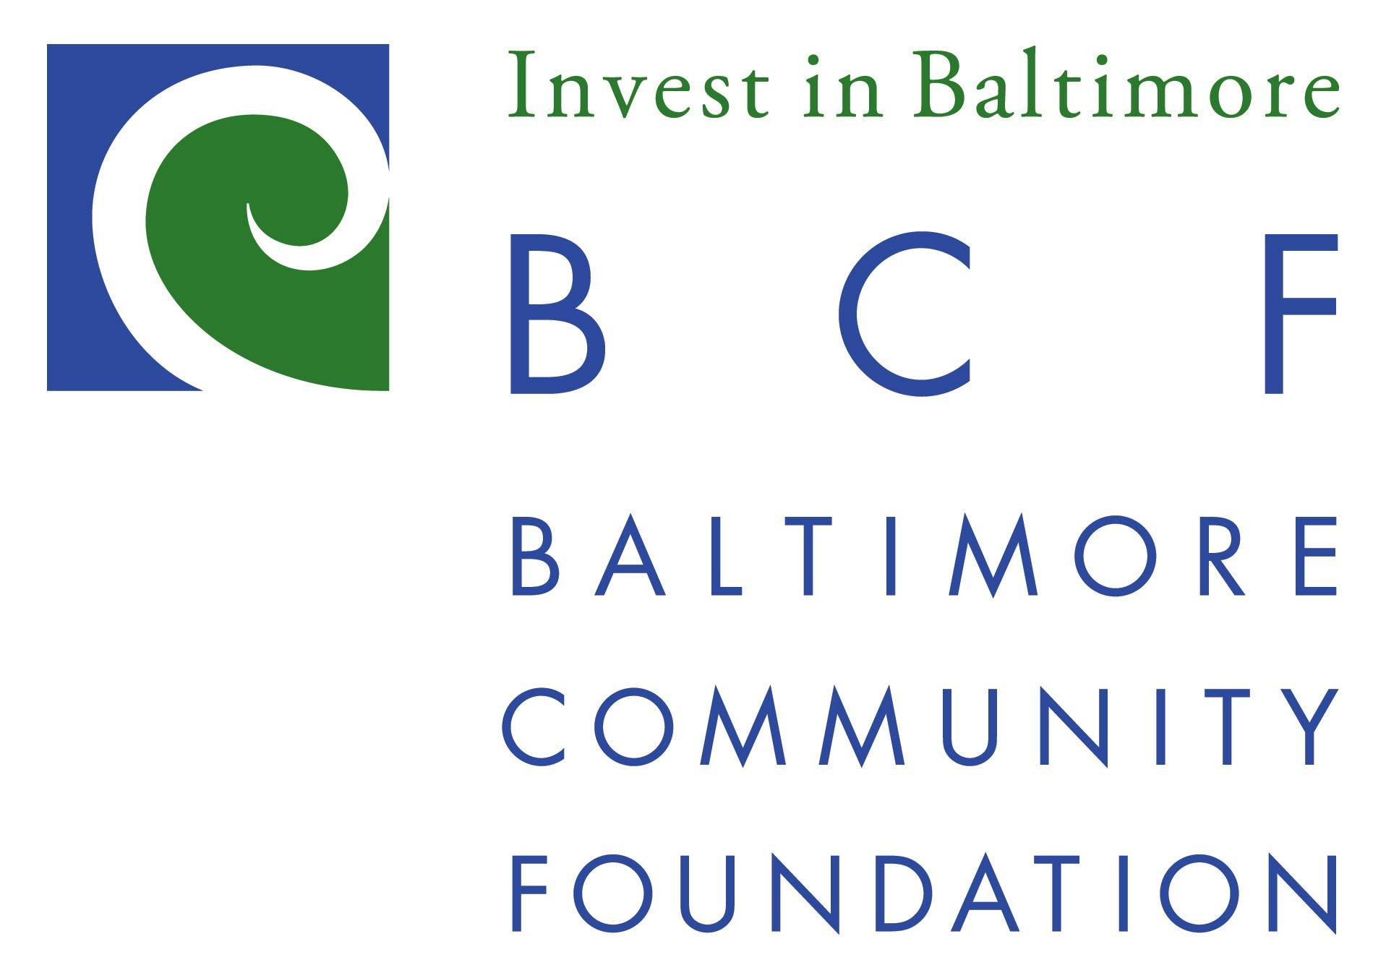

Position Openings: One (1) Youth Environmental Intern
Overview

The Baltimore Community Foundation seeks to hire 1 paid Youth Environmental Intern. This position will report to the Youth Sustainability Coordinator and will work closely with the Baltimore Office of Sustainability, Baltimore City Public Schools, and other partners. Current Baltimore City Public Schools high school students are eligible to apply (minimum 10th grade).

The newly hired Youth Environmental Intern will work with current Youth Environmental Interns on organizing, advocacy, and activism initiatives important to City School students both at the state and local level. The intern will engage in a previously developed anti-plastics campaign (Baltimore Beyond Plastic, www.bmorebeyondplastic.org), and will strategize ways of moving legislation forward using the youth voice. Students who have participated in Green Teams and greening activities at their schools or in other internship positions and programs are encouraged to apply.

Intern duties include:
- Organizing
  - Making presentations to student-comprised Green Teams at various schools and after-school programs and conducting follow up.
  - Organizing school-level actions and larger city-wide actions with teams.
  - Strategically developing advocacy plans with other Youth Environmental Interns to analyze political targets, points of leverage, and power structures.
- Advocating
  - Attending meetings with City Council members, experts, and state legislators
  - Be willing to speak publically at events
  - Conduct trategy meetings with lobbyists and other nonprofit partners
  - Supporting students’ legislative initiatives
- Event Planning
  - Significant behind-the-scenes event planning and prep including transportation planning, coordinating with teachers and Green Teams, determining event logistics, outreach to confirm attendees and follow up

Other duties will possibly include:
- Meeting weekly with the Youth Sustainability Coordinator
- Writing posts about internship activities on a shared blog.
- Attending and/or presenting at leadership trainings and conferences.
- Performing basic administrative tasks.
- Participating in outdoor experiences (e.g., canoeing/kayaking, tree plantings, hiking).
- Additional tasks as assigned.

Requirements
- Must be a current Baltimore City Public Schools high school student (min. 10th grade).
- Must have own phone and email and be able to check email regularly.
- Must be comfortable with basic computer skills (Microsoft Office, Google Drive, etc.)
- Ability to work some flexible hours, including evenings and weekends.
- Interest and comfort in working with teachers, peers, and volunteers.
- Excellent oral and written communication skills.
- A high level of organization, motivation, and enthusiasm.
- Prior involvement or interest in issues related to the environment, policy, and/or community organizing is strongly preferred. Examples include:
  - Membership on a Green Team
  - Participating in trash clean ups or tree plantings
  - Participating in Student Government Associations
  - Volunteering or working with issue campaigns or election campaigns

Compensation: $10/hour. No benefits are provided.
Commitment: Interns will be expected to work between 5 and 10 hours per week from October 2017 to June 2017

Location: The location of the position is flexible. Many meetings will be downtown at 417 E. Fayette Street, and others will be off site and at school locations.

To apply, please send a cover letter and resume to Andrea.Calderon@baltimorecity.gov by 5 pm on Friday, October 13, 2017.

