Greening Baltimore City Schools
Snapshots 2014-2015

In the 2014-2015 school year, the Green Healthy Smart Challenge and the Baltimore Energy Challenge made 60 grants for student-led environmental projects to 54 Baltimore City public schools, totaling $80,927. Over 1,300 students took led these projects as Green Team members, and many thousands more students, faculty, and community members were impacted. Five of our schools shared their stories in this video on Green Teams Transforming City Schools: https://vimeo.com/148273417
Read more about some of the amazing things that happened thanks to these programs:
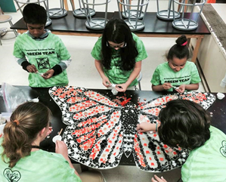
Armistead Gardens Elementary/Middle School
For their 2015 grant project, the Green Team planted a new butterfly garden and worked with a local artist to design and install three mosaics in the garden. The school certified the garden as a pollinator habitat with Monarch Watch, Pollinator Partnership, and Audubon Society, and installed awareness signage. “The Green Team is like my very own community. While I’m helping myself, I’m helping others around me.” – Sylvana, 5th grade

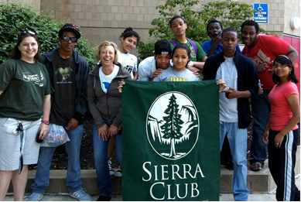
Digital Harbor High School
In 2015, Digital Harbor’s students worked with a volunteer mechanic to repair bikes and raised funds for a new school bike rack, also planted a new vegetable garden, went on nature outings, and engaged in energy conservation projects.
“One of the newer kids was recently enrolled in my class. She was homeless at her other high school. She’s just a very quiet little girl, but when we went to Outward Bound a few weeks ago, I’ve got this picture of her totally beatific. Yesterday in the garden, she was like “Can I pick one?” And then I showed her how to pick one and she’s like “What do I do?” If you don’t have access to fresh fruit or vegetables or you’ve never picked your own, it’s kind of a big deal to kids.” – Teacher Nicole Veltre
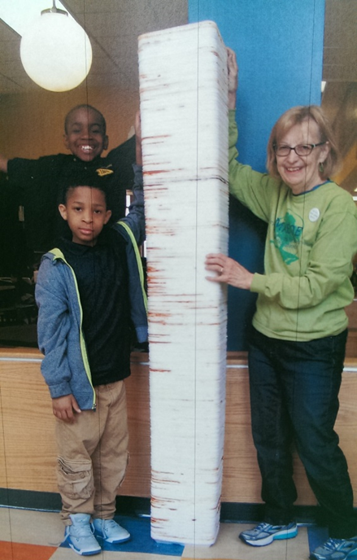
Commodore John Rodgers Elementary/Middle School
With their 2015 grant, Commodore John Rodgers students worked with the Patterson Park Audubon Center to plant a 20’x40’ native plant garden in their schoolyard and took a field trip to Morgan State University to see the new green building. Students participated in the city-wide Student Environmental Leadership Action Team, where they met the head of Recycling for the City’s Department of Public Works and learned that Styrofoam trays can be recycled if they are taken to a special facility. The Green Team students began collecting and rinsing lunch trays, which teachers took turns taking to be recycled. The school now collects 600-700 trays per day! Check out their “Greenam Style” video: https://www.youtube.com/watch?v=5TFUuvOfo38
“I think it’s part of the culture of the school now. I ask the students if they’re recycling at home and they say yes now.” – Guidance Counselor Tony Krebs

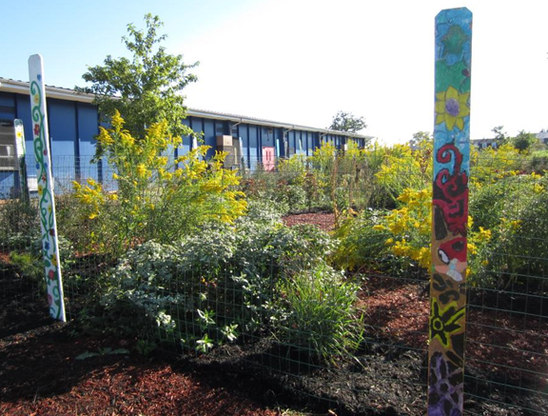
Lakeland Elementary/Middle School
In 2015, Lakeland’s Green Team expanded their school garden and certified it as an Eco-Habitat, conducted an awareness campaign with signs and posters around the school, and created model wind turbines that generated real energy. They are now a certified Maryland Green School! See more of their work at http://lakelandgreenschool.weebly.com/.
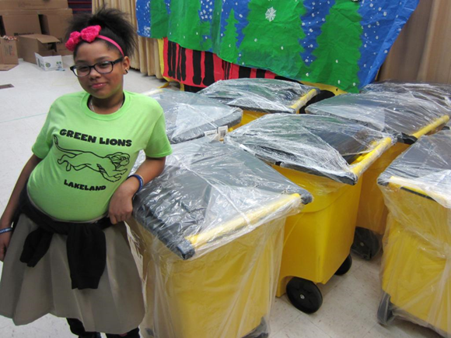
“Seeing the students design their own wind turbines, using their engineering skills to design the blades, and getting excited when I bought out the box fan and we tested how much power they were creating, that was a really cool moment for me. Having them take ownership of the environment, like, oh, I shouldn’t blatantly litter outside, and, hey, there are really beautiful places where you can go to enjoy nature… that’s been really rewarding as well.” – Teacher Zach Pechor
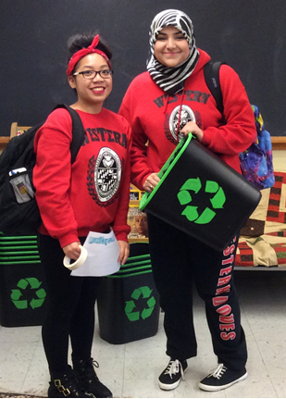
Western High School
Western’s 2015 Green Team painted 50 trash cans to turn them into new recycling bins, which were distributed to classrooms along with educational signage. To encourage participation, the team read weekly green-themed facts during the morning announcements, and distributed thank-you notes and chocolates. At the annual school fair, Green Team members sold plants, played recycling games, and educated students and staff on environmental stewardship.
“The biggest impact that our club made this year with the help of The Green Healthy Smart Challenge has to be the fact that we had the opportunity to buy recycling bins for the school, which gave the members of the club a reason to promote recycling in the classrooms and actually spread awareness to other students and faculty.” – Hiba Jamil, Green Team founder and president

GreenScape 2015
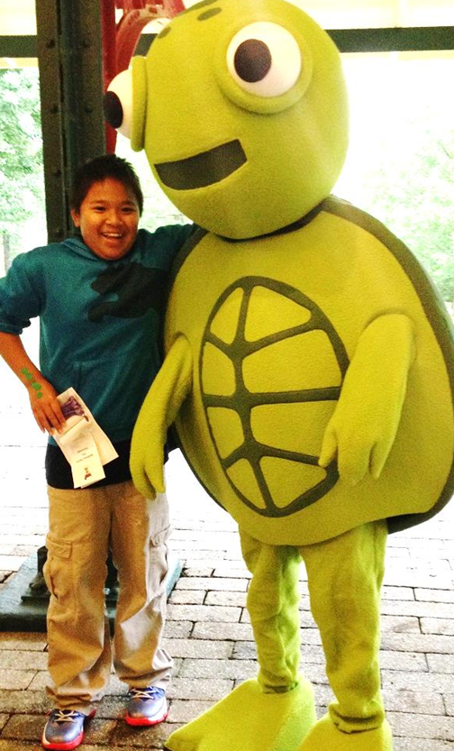
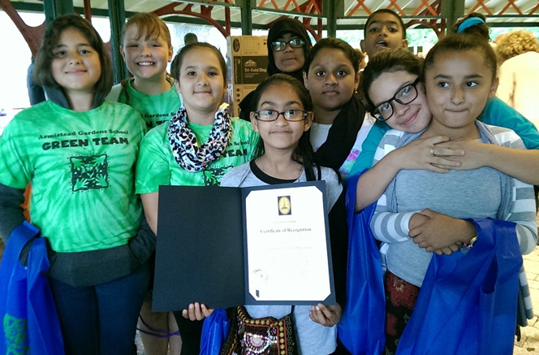
More than 200 students, parents, teachers, and partners gathered at the Maryland Zoo in May 2015 for our annual celebration. Students shared their successes via speeches and displays, participated in activities with more than a dozen partner organizations, tasted delicious local vegetarian food, received Mayoral certificates of appreciation, and won prizes donated by local businesses, including a brand new bike!
Learn more about our work at http://www.baltimoresustainability.org/projects/green-schools-initiative/

